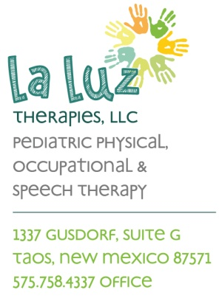

**La Luz Therapies, LLC.**

**Patient’s Bill of Rights**

1. The right to efficient and equal service, regardless of their race, sex, religion, ethnic background, education, social class, physical or mental handicap, or economic situation.
2. The right of considerate, courteous, and respectful care from all staff of the facility.
3. The right of complete information in terms the average patient can reasonably be expected to understand.
4. The right to informed consent and full discussion of risks and benefits prior to any invasive procedure, except in an emergency. Alternatives to the proposed must be discussed with the patient.
5. The right to obtain assistance in interpretation for non-English speaking patients.
6. The right to know the names, titles, and professions of the facility staff to whom the patient speaks and from whom services or information are received.
7. The right to refuse examination, discussion, and procedures to the extent permitted by law and to be informed of the health and legal consequences of this refusal.
8. The right of access to patient’s personal health records.
9. The right of respect for the patient’s privacy.
10. The right of confidentiality of the patient’s personal health records as provided by law.
11. The right to expect reasonable continuity of care within the scope of services and staffing of the facility.
12. The right of respect for the patient’s civil rights and religious opinions.
13. The right to present complaints to the management of the facility without fear of reprisal.
14. The right to examine and receive a full explanation of any charges made by the facility regardless of source of payment.

I have read and understood the above:

__________________________________________ _________________________

Signature of Patient or Responsible Party Date